

Project Management Plan

**Version1.5**

**Quốc Nhân**

**09/11/2019**

**VERSION HISTORY**

|  |  |  |  |  |  |
| --- | --- | --- | --- | --- | --- |
| **Version #** | **Implemented**  **By** | **Revision**  **Date** | **Approved**  **By** | **Approval**  **Date** | **Reason** |
| 1.0 | Quốc Nhân | 30/10/2019 |  |  | Create Document version 1.0 |
| 1.1 | Quốc Nhân | 31/10/2019 |  |  | Edit Document version 1.1 |
| 1.2 | Quốc Nhân | 1/11/2019 |  |  | Edit Document version 1.2 |
| 1.3 | Quốc Nhân | 4/11/2019 |  |  | Update Milestone v1.3 |
| 1.4 | Quang Vương | 09/11/2019 | Team | 09/11/2019 | Team review and update |
| 1.5 | Quốc Nhân | 12/11/2019 |  |  | Update content scope v1.5 |
| 1.6 | Quốc Nhân | 14/11/2019 |  |  | Update scope v1.6 |

Table of Contents

1. Introduction 3

2. Purpose 3

3. Scope And RESTRICTIONS 3

3.1 Scope 3

3.2 Limit and difficult 3

**4.** **COMMERCIAL CONTEXTS 8**

4.1 Priority 8

4.2 Environment Operating 8

4.3 Milestone 8

4.4 Risk Plant 9

**5.** **PLANNING AND ACCESSING THE PROJECT 9**

5.1 Process 9

5.2 Role and Responsibility 10

**6.** **PRODUCT 10**

**7.** **SCHEDULE 10**

**8.** **RISK MANAGE 10**

**9.** **COMMUNICATE PLAN 10**

**10.** **CONFIGURATION PLAN 10**

# 

# Introduction

Today, information technology is developing day by day. Convenience companies are also mushrooming like app grabs on traffic, app now on food, so housing is an important issue. important to people today. The introduction of real estate management application will solve current problems for everyone.

- App real estate is an internal tool that can interact with each other

- Help managers easily control the information.

- App also helps customers get the necessary information about a land.

# Purpose

The objective of the document is to describe the workflow, schedule, functions and problems of the real estate project.

# Scope

## Scope

|  |  |  |  |
| --- | --- | --- | --- |
| **ID** | **FUNCTION** | **DESCRIPTION** | **CLASSIFY** |
| **Account management** | | | |
| FR.01 | Login | Users are provided accounts from the admin | Employees, department head, director and administrator |
| FR.02 | Logout |
| FR.03 | View account information |  | Administrator |
| FR.04 | Search personnel list | Users can search for personnel | Employees, department head, director and administrator |
| FR.05 | View personnel list | View image on app | Employees, department head, director and administrator |
| FR.06 | Upload organizational chart | Admin upload & add organizational chart | Administrator |
| FR.07 | View organizational chart | View image on app | Employees, department head, director and administrator |
| FR.08 | Add business trip fees regulations | Admin add business trip fees regulations from image | Administrator |
| FR.09 | View business trip fees regulations | View image on app | Employees, department head, director and administrator |
| FR.10 | Add normal salary regime | Admin add normal salary regime from image | Administrator |
| FR.11 | View normal salary regime | View image on app | Employees, department head, director and administrator |
| FR.12 | Add holiday schedule | Admin add holiday schedule from image | Administrator |
| FR.13 | View holiday schedule | View image on app | Employees, department head, director and administrator |
| FR.14 | Add personnel appointment | Add from image | Administrator |
| FR.15 | View personnel appointment | View image on app | Employees, department head, director and administrator |
| FR.16 | Add team building activity | Add from image | Administrator |
| FR.17 | View team building activity | View image on app | Employees, department head, director and administrator |
| FR.18 | Add account |  |  |
| FR.19 | Hide account |  |  |
| FR.20 | Edit account |  |  |
| FR.21 | Decentralization |  |  |
| **Real estate project management** | | | |
| FR.22 | View real estate listings |  | Employees, department head, director and administrator |
| FR.23 | Search real estate listings |
| FR.24 | Add real estate listings |  | Administrator |
| FR.25 | Edit real estate listings |
| **Statistical management, reporting** | | | |
| FR.26 | View business results week | After the admin receives statistical information, reports from the company, the admin will display on the app | Employees, department head, director and administrator |
| FR.27 | Upload business results week | After the admin receives statistical information, reports from the company, the admin will upload on the app | Administrator |
| FR.28 | Search business results week |  | Employees, department head, director and administrator |
| FR.29 | View table comparing business results |
| FR.30 | View graph of business results |
| **Business trip manager** | | | |
| FR.31 | Sign up for business trip | Employees, department head, director and administrator will register the business trip | Employees, department head, director and administrator |
| FR.32 | Browse business trip | Director & department head will confirm | Director, departments head |
| FR.33 | Cancel business trip | Director & Head of Department will refuse | Director, departments head |
| FR.34 | Locate business trip | After completing the business trip | Employees, department head, director and administrator |
| FR.35 | View business trip history | Entire company can review history | Employees, department head, director and administrator |
| FR.36 | Search business trip history |  | Employees, department head, director and administrator |
| **Management quit** | | | |
| FR.37 | Register to quit your job | Employees, department head, director and administrator will register the day off | Employees, department head, director and administrator |
| FR.38 | History of leave | Entire company can review history | Employees, department head, director and administrator |
| FR.39 | Approval of leave | Director & department head will review and approve the leave | Director, departments head |
| FR.40 | Search of leave |  | Employees, department head, director and administrator |
| **Other functions** | | | |
| FR.41 | Happy Birthday | The app will display a happy birthday notification for everyone (on staff's birthday). | System (popup) |

## Limit and Difficult

* Need time to train staff, use instructions.
* The system does not work without the Internet.

# Commercial contexts

## Priority

|  |  |
| --- | --- |
| **Requirets** | **Priority** |
| Account management | High |
| Project management | High |
| Statistical management, reporting | High |
| Business trip manager | High |
| Management quit | High |
| Other functions | Low |

## Environment Operating

* Android studio
* Xcode
* Visual Studio Code
* WindowOs
* MacOs
* Nodejs

## Milestone

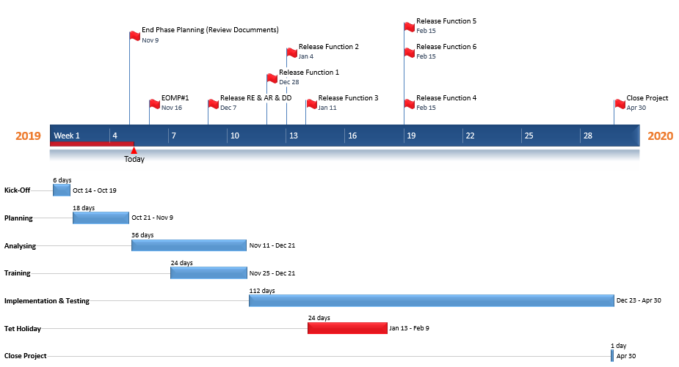

## Risk

* Not familiar with the tools used in the project (GIS, Android, IOS)
* Not knowing about the operation of a real estate project
* Not proficient in programming languages ​​and map systems (Android, IOS)
* Due to lack of practical experience of real estate project

1. **Planning and accessing the projects**

## Process

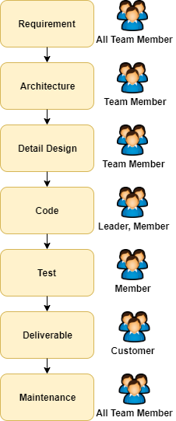

## Role and Responsibility

|  |  |
| --- | --- |
| **Role** | **Responsibility** |
| Mentor | Managing teamwork  Direct contact with stakeholders  Guide the team to the project |
| Project Team | Do & develop real estate projects |
| Customer | Guide business processes, tools  Approve the product |

1. **Product**

|  |  |
| --- | --- |
| **Product** | **Detail** |
| Package installation | Source Codes and Database |
| Installation instructions |
| User guide |
| Requirement Document | Concept of Operations |
| Software Requirement |
| Design Document | Architectural Driver |
| Architectural Design |
| Detail Design |
| Database Document | Database Design |

1. **Schedule**



**PM_WorkBreakdownStructure**

1. **Risk management**



**PM_RiskManagementPlan_Ver1.0**

1. **Communicate plan**



**PM_CommunicationPlan_Ver1.2**

1. **Configuration plan**



**PM_ConfigurationManagementPlan_Ver1.0**